**Automating Helmet Enforcement With Yolov9: A Deep Learning Approach**

**Sustainable Utilization of Wollastonite Microfibres............... Venkatesan, et al**

# Harsh Sanjaysingh Kachhaway

Student

Department of Computer Science and Engineering

Govindrao Wanjari College of Engineering & Technology, Salai gadhani, Maharashtra

 [harshkachhaway8001@gmail.com](mailto:harshkachhaway8001@gmail.com)

# Gaurav Dnyaneshwar Dupare

Student

Department of Computer Science and Engineering

Govindrao Wanjari College of Engineering & Technology, Salai gadhani, Maharashtra

# Tushar Marotrao Maske

Student

Department of Computer Science and Engineering

Govindrao Wanjari College of Engineering & Technology, Salai gadhani, Maharashtra

**Tushar Manesh Shinde**

Student

Department of Computer Science and Engineering

Govindrao Wanjari College of Engineering & Technology, Salai gadhani, Maharashtra

# Shivam Shivkumar Shukla

Student

Department of Computer Science and Engineering

Govindrao Wanjari College of Engineering & Technology, Salai gadhani, Maharashtra

# Nitin Thakre

Professor

Department of Computer Science and Engineering

Govindrao Wanjari College of Engineering & Technology, Salai gadhani, Maharashtra

# ABSTRACT

Motorcycle helmets are essential safety equipment designed to protect riders during accidents; however, many motorcyclists fail to wear them or use them improperly despite legal mandates in various countries. This study presents a real-time automated system for helmet detection and license plate recognition using You Only Look Once (YOLOv9), a deep learning-based object detection model. The system detects five key object classes: Helmet, No Helmet, Motorbike, Person, and License Plate. Once a rider without a helmet is identified, the system extracts the license plate coordinates, crops the plate region, and processes it using an Optical Character Recognition (OCR) model to convert the text into machine-readable form. The OCR output with the highest confidence score is selected for accurate recognition and stored for future use. The proposed system demonstrates high accuracy and real-time performance, making it suitable for deployment with CCTV or webcam systems. By leveraging open-source tools and libraries, the solution is cost-effective, adaptable, and capable of automating helmet detection and enforcement. This approach enhances road safety, streamlines traffic regulation enforcement, and encourages safer riding habits by identifying and penalizing helmet violations.

***KEYWORDS:*** *YOLO, Helmet Detection, Real-time detection, IP Webcam, CCTV footage.*

# INTRODUCTION

M

otorcycle helmets are essential safety gear

designed to protect riders during accidents.

Despite being mandatory in numerous countries, some motorcyclists either neglect to wear helmets or use them improperly. Over recent years, significant progress has been made in traffic analysis, focusing on areas like vehicle detection, classification, and helmet usage detection. Advanced traffic monitoring systems have been developed using computer vision techniques, such as background and foreground segmentation to isolate moving objects and feature extraction through image descriptors. Additionally, computational intelligence methods, including machine learning algorithms, have been applied to identify and classify objects.Machine learning, a subset of Artificial Intelligence, involves training models on specific datasets to enable automated decision-making and prediction without manual intervention. These algorithms analyze training data to create mathematical models capable of identifying patterns and making accurate classifications. In the context of helmet detection, machine learning can be leveraged to develop models that identify helmet-less riders. Upon detecting a violation, the system can extract the rider's license plate from the image and save it. The license plate image is then processed using Optical Character Recognition (OCR) technology to convert it into machine-readable text, providing the license plate number as output.This approach can be further enhanced for real-time implementation using a webcam or CCTV cameras. The primary goal of such a system is to promote helmet usage, encourage safer riding habits, and ultimately reduce the frequency and severity of motorcycle accidents. By integrating computer vision and machine learning, this solution can play a pivotal role in enforcing traffic regulations and improving road safety

# METHODOLOGY

For effective real-time helmet detection, achieving both high accuracy and fast processing speed is essential. To meet these requirements, a deep neural network-based model, You Only Look Once (YOLO), has been selected. YOLO is a cutting-edge object detection system known for its real-time performance.Among its versions, YOLOv9 stands out due to its remarkable speed and accuracy, offering significant improvements over earlier iterations. Unlike methods like R-CNN, which require multiple evaluations per image, YOLOv9 predicts objects in a single network evaluation. This efficiency makes it exceptionally fast—more than 1000 times faster than R-CNN and 100 times faster than Fast R-CNN.Object detection involves identifying and locating specific classes, such as people, vehicles, or other items, within images or videos. While pre-existing object detection APIs can simplify this process using pretrained models, these models often detect irrelevant objects. To address this, a custom object detector is necessary to focus on specific classes relevant to the task.For implementing helmet detection and license plate recognition, five objects need to be identified: Helmet, No Helmet, Motorbike, Rider (person on the bike), and License Plate. A custom object detection model is created to recognize these classes. This process begins with collecting a dataset of images containing the target objects. The dataset is then used to train the custom model.The model training leverages convolutional neural networks (CNNs), a type of deep learning classifier, to extract and store object features. Once trained, the model can detect the specified objects in images by comparing the extracted features to those in the training dataset. Examples of detections are often used to demonstrate the model's capabilities and effectiveness in identifying these custom objects.

**Helmet Detection**

Annotated images are used to train the YOLOv9 model for custom object classes. After training, the generated weights are loaded into the model. Once the training process is complete, the model can process input images and detect the five specified classes. Using this detection, it identifies whether a motorbike rider is wearing a helmet. If the rider is detected without a helmet, the model retrieves information about the other relevant classes, which can then be used to locate and extract the license plate.

**License Plate Extraction**

When a helmetless rider is identified, the model associates the detected "no helmet" class with the corresponding "person" class by checking if the coordinates of the "no helmet" detection fall within the boundaries of the "person" detection. A similar process is used to identify the associated motorbike and license plate. Once the license plate's coordinates are determined, the plate is cropped from the image and saved as a separate file for further processing.

**License Plate Recognition**

The cropped license plate image is fed into an Optical Character Recognition (OCR) model, which identifies and extracts the text present on the license plate. The OCR processes the input image and outputs the detected text in a machine-readable format. Along with the recognized text, the OCR also provides a confidence score, indicating the reliability of the prediction. Among the predicted results, the license plate number with the highest confidence score is selected and stored in a text file for further processing or use.

# MODELING AND ANALYSIS

**The Real-Time Processing Using a Webcam**

The system supports real-time object detection by utilizing a webcam as the primary input device to capture image frames. The YOLOv9-tiny model is implemented for this task, as it offers an optimal balance between speed and accuracy. With the YOLOv9-tiny model, the system is capable of processing up to 220 frames per second (fps), making it suitable for real-time video analysis. Each frame captured by the webcam is passed to the trained object detection model, which efficiently detects and classifies the relevant objects, including helmets, riders without helmets, motorbikes, and license plates. The high processing speed ensures minimal delays and enables smooth real-time monitoring, which is essential for traffic surveillance systems. This approach makes the system ideal for static installations, such as traffic monitoring stations or CCTV-based setups, where a fixed camera continuously monitors a specific area for helmet violations and license plate extraction.

**Mobile Camera Integration Using IP Webcam**

In addition to using a standard webcam, the system can integrate a mobile device camera as an input source through IP Webcam technology. This method involves using a mobile phone's camera to capture live video streams, which are then transmitted to the detection system via an IP address. Using mobile cameras as input devices offers significant advantages over static webcams, as they provide greater flexibility and mobility. Unlike fixed cameras, a handheld mobile device can be easily repositioned to capture footage from different angles and locations, ensuring better coverage of dynamic environments such as busy intersections or crowded roads.The mobile camera’s proximity to the objects being monitored also enhances the clarity and resolution of the captured frames, particularly for license plate detection. With closer and more detailed footage, the Optical Character Recognition (OCR) module can extract the license plate numbers with higher precision, minimizing errors and improving accuracy. The mobile-based system can be employed not only for traffic surveillance but also for portable enforcement, allowing personnel to use handheld devices for real-time helmet detection and license plate recognition in various scenarios.By integrating mobile cameras, the system is no longer restricted to fixed installations like CCTV footage. It can effectively expand its scope to include dynamic and on-the-go monitoring solutions. This versatility is particularly useful for areas where setting up fixed cameras is not feasible or cost-effective. 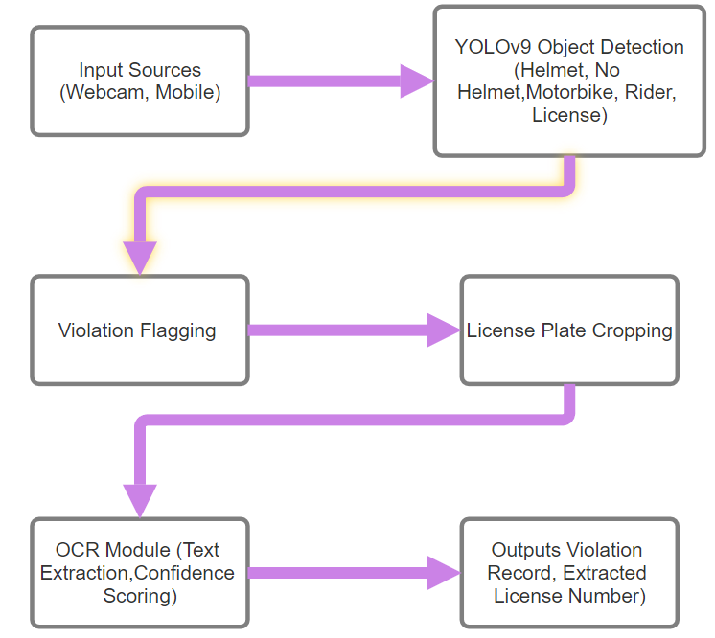

**Figure 1.Block digram**

Additionally, mobile-based footage is often clearer due to its proximity to the vehicles, ensuring better detection results for both the YOLOv9-tiny model and the OCR module. The portability of mobile devices enables authorities to cover larger areas more efficiently while maintaining high accuracy in detecting helmet violations and extracting license plate information in real-time.In conclusion, combining webcam-based and mobile-based input systems enhances the flexibility, usability, and effectiveness of the helmet detection and license plate recognition system. Both input methods cater to different monitoring scenarios, ensuring a scalable solution that can operate in fixed and dynamic environments while delivering high-performance real-time results.

# RESULTS

The proposed system for helmet detection and license plate recognition was successfully implemented and tested, showcasing the effectiveness of the YOLOv9 model in real-time detection of custom classes, including Helmet, No Helmet, Motorbike, Person, and License Plate. The model accurately identified motorcyclists with and without helmets, with the detection of the "No Helmet" class triggering the subsequent processes of identifying the associated rider, motorbike, and license plate. The license plate coordinates were precisely detected, allowing the plate region to be accurately cropped and saved as an image for further processing. The OCR model efficiently extracted text from the cropped license plate images and selected the license plate number with the highest confidence score, which was then stored in a text file for record-keeping. The system achieved high detection accuracy, real-time performance, and reliable license plate recognition, validating its capability to enforce helmet usage and identify helmetless riders through automated detection and recognition techniques

# CONCLUSIONS

The results obtained demonstrate that the YOLO object detection model is highly effective for real-time processing, accurately detecting and localizing all the specified object classes. The proposed end-to-end system was successfully developed and is capable of full automation, making it suitable for deployment in real-world monitoring scenarios.To ensure robust license plate extraction, additional techniques were implemented to address various challenges, such as detecting multiple riders without helmets. The system is designed to handle a wide range of possible cases efficiently.The project utilized open-source libraries and software, making it both cost-effective and highly adaptable for further customization or integration. The primary goal of this system was to address the inefficiencies in traffic management, particularly with regard to helmet detection and rider identification.In conclusion, this system has the potential to significantly assist traffic management authorities by automating helmet detection and license plate recognition, ultimately enhancing efficiency and improving road safety

# ACKNOWLEDGEMENTS

# I wish to express my deep sense of gratitude to Govindrao Wanjari College of Engineering and Technology, Nagpur, for providing me with the opportunity to fulfill my most cherished goal. My heartfelt thanks to our Principal, Dr. S. A. Chavan, for the invaluable support and encouragement extended to me throughout the completion of my project.

# I extend my immense gratitude to the Head of the Department, Prof. Vivekanand P. Thakare, for his continuous motivation, inspiration, and unwavering support, which played a pivotal role in the successful completion of my project.

# I would like to take this opportunity to express my sincere thanks to my guide, Prof. Nitin Thakre. His energy, creativity, and exceptional coding skills have been a constant source of motivation and have significantly contributed to the successful completion of my project.

# Lastly, but certainly not the least, I express my heartfelt gratitude to my parents, relatives, friends, and all those whose support, encouragement, and unseen contributions were integral to the realization of this dissertation.

# REFERENCES

1. Zhou F, Zhao H, Nie Z. Safety helmet detection based on YOLOv5. In2021 IEEE International conference on power electronics, computer applications (ICPECA) 2021 Jan 22 (pp. 6-11). IEEE.
2. Waranusast R, Bundon N, Timtong V, Tangnoi C, Pattanathaburt P. Machine vision techniques for motorcycle safety helmet detection. In2013 28th International conference on image and vision computing New Zealand (IVCNZ 2013) 2013 Nov 27 (pp. 35-40). IEEE.
3. Tan S, Lu G, Jiang Z, Huang L. Improved YOLOv5 network model and application in safety helmet detection. In2021 IEEE International Conference on Intelligence and Safety for Robotics (ISR) 2021 Mar 4 (pp. 330-333). IEEE.
4. Jia W, Xu S, Liang Z, Zhao Y, Min H, Li S, Yu Y. Real‐time automatic helmet detection of motorcyclists in urban traffic using improved YOLOv5 detector. IET Image Processing. 2021 Dec;15(14):3623-37.
5. Li K, Zhao X, Bian J, Tan M. Automatic safety helmet wearing detection. arXiv preprint arXiv:1802.00264. 2018 Feb 1.
6. Wu F, Jin G, Gao M, Zhiwei HE, Yang Y. Helmet detection based on improved YOLO V3 deep model. In2019 IEEE 16th International conference on networking, sensing and control (ICNSC) 2019 May 9 (pp. 363-368). IEEE.
7. Yung ND, Wong WK, Juwono FH, Sim ZA. Safety helmet detection using deep learning: Implementation and comparative study using YOLOv5, YOLOv6, and YOLOv7. In2022 International Conference on Green Energy, Computing and Sustainable Technology (GECOST) 2022 Oct 26 (pp. 164-170). IEEE.
8. Li Y, Wei H, Han Z, Huang J, Wang W. Deep learning‐based safety helmet detection in engineering management based on convolutional neural networks. Advances in Civil Engineering. 2020;2020(1):9703560.
9. Huang L, Fu Q, He M, Jiang D, Hao Z. Detection algorithm of safety helmet wearing based on deep learning. Concurrency and Computation: Practice and Experience. 2021 Jul 10;33(13):e6234.
10. Rubaiyat AH, Toma TT, Kalantari-Khandani M, Rahman SA, Chen L, Ye Y, Pan CS. Automatic detection of helmet uses for construction safety. In2016 IEEE/WIC/ACM International Conference on Web Intelligence Workshops (WIW) 2016 Oct 13 (pp. 135-142). IEEE.